**Where are Ashoka's rock edicts and pillars?**

**Explore national symbols and their meanings.**

*Keywords:  Emperor Ashoka, national symbols, Buddhism, edicts, Maurya, Mauryan Empire, Brahmi Script, dhamma, dharma, Jataka tales, world history, giant empires, religion, non-violence, religion and government, social justice, human rights*

Emperor Ashoka (304-232 BCE) was the third king of the Maurya Dynasty.  He ruled a truly massive kingdom that stretched from the Hindu Kush to the Bay of Bengal.  It was India's first great empire.  It is not just that Ashoka ably ruled this huge empire but the quality of social justice that he brought to his already strong administration.

Remorseful after his bloody campaign and conquest of Kalinga, Ashoka embraced Buddhism.  Thereafter reverence for life, tolerance, compassion and peaceful co-existence were the cornerstones of his administration. Under him the earliest know bans on slavery and capital punishment as well as environmental regulations came into place.

**Sites of Ashoka rock and pillar edicts**

Source: <http://www.sas.upenn.edu/~dludden/H088_05_Frameset.htm>

[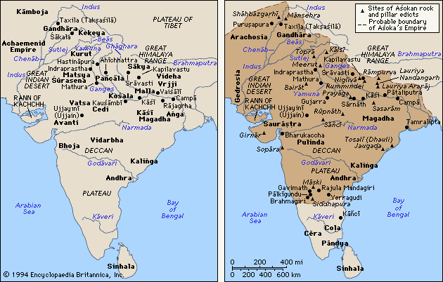](http://www.sas.upenn.edu/~dludden/H088_05_Frameset.htm)

[Top](http://www.teachindiaproject.org/Where_are_Ashoka_rock_edicts_and_pillars.htm#Top)

This is what Ashoka declared in one of his inscriptions:

*“Eight years after becoming king I conquered Kalinga.*

*About a lakh and a half people were captured. And more than a lakh of people were killed.*

*This filled me with sorrow. Why?*

*Whenever an independent land is conquered, lakhs of people die, and many are taken prisoner. Brahmins and monks also die.*

*People who are kind to their relatives and friends, to their slaves and servants die, or lose their loved ones.*

*That is why I am sad, and have decided to observe dhamma, and to teach others about it as well.*

*I believe that winning people over through dhamma is much better than conquering them through force.*

*I am inscribing this message for the future, so that my son and grandson after me should not think about war.*

*Instead, they should try to think about how to spread dhamma.”*

(‘Dhamma’ is the Prakrit word for the Sanskrit term ‘Dharma’).

Assignment- You will make your own Pillar, like the ones ASOKA placed throughout his kingdom.

* What will you promote?
  + How great you are…
  + Your amazing accomplishments…
  + Advise for your countrymen
  + Jokes to brighten someone’s day
* Include 3 facts from what we’ve covered so far in unit 3 (notes, map, videos, ect.)
* Worth 12 points
  + 3 pts. for each fact
  + 3 pts. for neatness and creativity with pillar